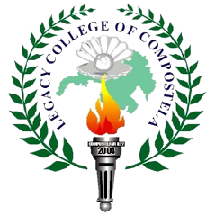 | LEGACY COLLEGE OF COMPOSTELA  Dagohoy Street, Poblacion, Compostela, Davao de Oro  “Quality Education Within Reach”  INSTITUTE OF INFORMATION TECHNOLOGY (IIT)  School Year 2025-2026 | 

Recommendation for Title Defense
In partial fulfillment of the requirements for the degree Bachelor of Science in Information Technology, these Capstone Project proposals entitled:

1.
2.
3.

has been prepared and submitted by <<Names of students in alphabetical order based on last names, format: first name middle initial last name>> and is recommended for a title defense.

<Name of Project Adviser>
Project Adviser

Date Signed: ____________

